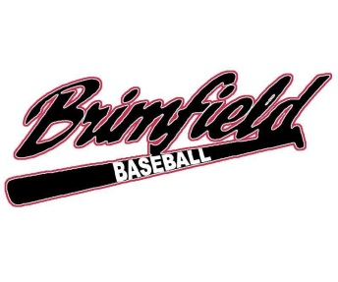 Brimfield Athletic Association 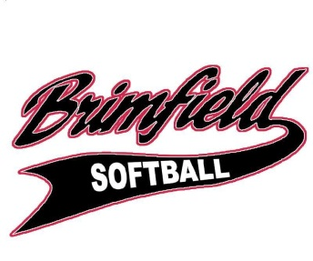
Phone: 330-221-8098

2014 Sponsorship Form

____________________________________________________________________________________________________________
Company Name

____________________________________________________________________________________________________________
Address

____________________________________ _______________________ _____________________
City State Zip

___________________________________________ _________________________________________________________
Email Address Website URL

_________________________________________________ __________________________________________________
Business Phone #1 Business Phone #2

The Brimfield Athletic Association appreciates and thanks you for your support! Please select your sponsorship package(s) from the list below. Also remember donations are tax deductible.

Sponsorship Packages Cost

Company name on team uniform, team banner and a team picture $300
Donors plaque placed on the concession stand $50
3’ x 4’ custom sign placed on the outfield fence for 1 year $250
3’ x 4’ custom sign placed on the field backstop for 1 year $350
(One per field, only four (4) available)
4’ x 8’ custom sign placed on the wall facing the fields for 2 years $500
One (1) year renewal of any existing custom sign $75
Combination of team uniform and any custom sign -$50
Open donation amount $

TOTAL: $___________________________________

Please make checks or money orders payable to the B.A.A. and mail to the following by March, 14 2014.

B.A.A.
1263 Sandy Lake Road
Ravenna, Ohio 44266

